**COOKING RECIPE SHARING WEB APP**

1. **REGISTER A DOMAIN**

The first thing you need to be aware to complete this project is that you will need to have a registered domain.

So, in order for us to continue, either you already have a registered domain in Route53 or another domain register such as GoDaddy, or you will need to purchase one.

I this section I will guide you on how you can register a domain in Route 53, or how you can set up DNS management in Route 53 for a domain bought outside Route 53.

1. **PURCHASE A DOMAIN NAME THROUGH AWS ROUTE 53**

* **Open Route 53**: In the AWS console, go to Route 53
* **Go to “Registered Domains”**:

On the left panel, click on Registered Domains.

Select Register Domain.

* **Search for Domain Name**:

In the search box, type the domain name you want.

Click Check to see if it’s available.

AWS will display similar domain extensions (like .com, .net, .org) with their prices.

* **Choose a Domain and Add to Cart**:

Select your preferred domain extension by checking the box next to it.

Click Add to Cart.

* **Review Cart and Continue**:

Review the domain you’ve added and click Continue.

* **Enter Contact Information**:

Enter your contact details (AWS requires this for domain registration).

Select the option to enable Privacy Protection if you want to keep your information private.

* **Review and Purchase**:

Review the domain name, contact information, and privacy settings.

Select the 1-year registration or adjust as desired.

Accept the terms of service, and click Complete Order.

* **Confirm Payment**:

AWS will charge your account for the domain cost. You may need to set up or confirm your payment method if it’s not already on file.

* **Verify Your Email**:

After registration, AWS will send an email for verification. Follow the link in the email to complete the domain registration.

* **Access Your Domain in Route 53**:

Once verified, the domain will appear under Registered Domains in Route 53.

1. **ADD YOUR DOMAIN BOUGHT OUTSIDE ROUTE 53**

* **Open Route 53**: In the AWS console, go to Route 53
* Click on **Hosted Zones**.
* Then, select **Create Hosted Zone**.
* Fill the **Domain name** field with the domain you own.
* Select **Public Hosted Zone** as the type.
* Press **Create Hosted Zone**.

1. **REQUEST A PUBLIC CERTIFICATE**

You will now proceed with the certificate-issuing process with the AWS Certificate Manager (ACM) service:

* From the AWS console, go to the ACM service
* Click on the **Request a certificate** button.
* On the Certificate Type screen, select the **Request a public certificate** option and click Next.
* Fill out the required information on the form. Most fields can be left with their default values, but for the **Fully qualified domain name** field, you have two options:

**Option A:** Generate separate certificates for each subdomain (e.g., app.example.com, api.example.com).

**Option B:** Use a wildcard certificate that will be valid for all subdomains (e.g., *.example.com). See image 1.1

* Ensure that **Validation method** is set to **DNS validation**, as recommended by AWS.
* Click **Request**.

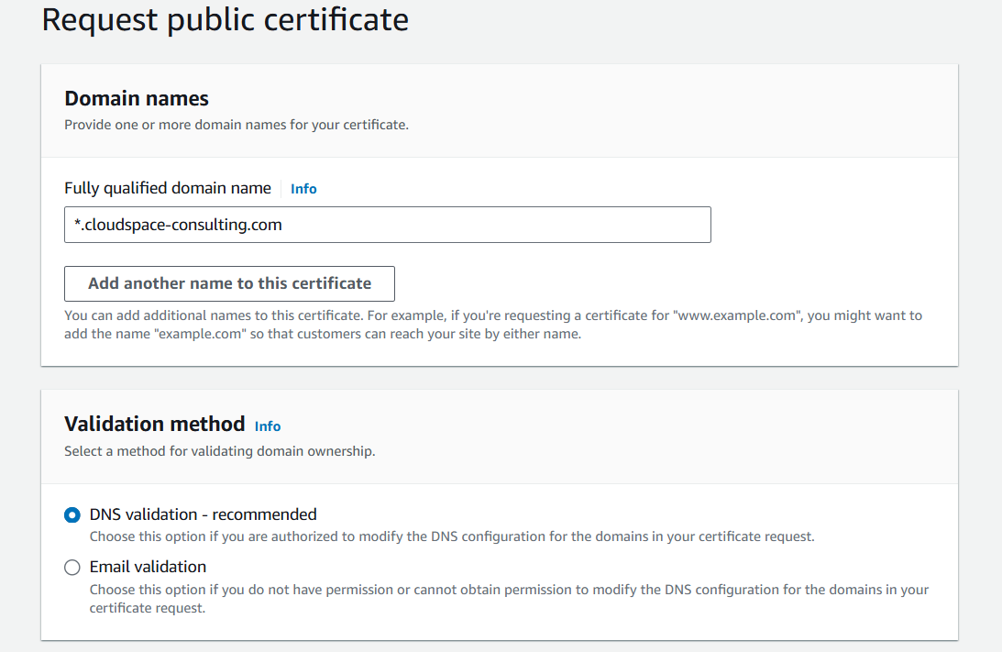

Image 1.1 – Certificate request form

After requesting the certificate, you will see it listed with the pending validation status. To validate the certificate and prove domain ownership, you need to create a DNS record in your hosted zone.

If your domain is managed by Route 53, you can click **Create Records in Route 53** for an easier setup, as you can see in image 1.2.

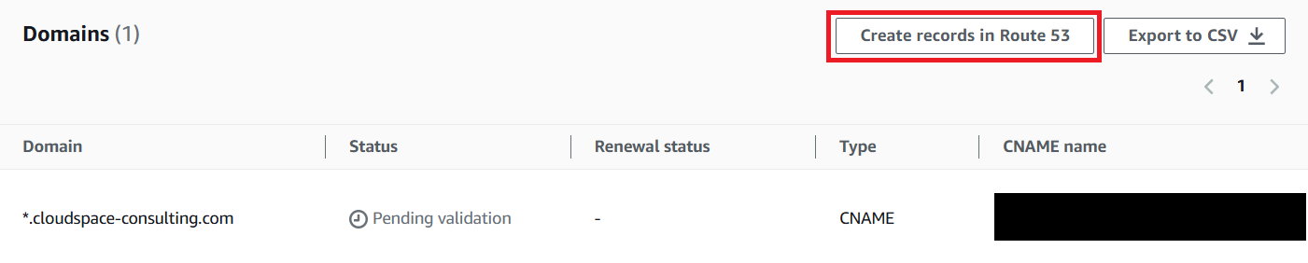

Image 1.2 – Certificate validation with a DNS record

Before proceeding, you need to wait until the status changes to **Issued** as in Image 1.3. If everything is well configured, it should not take more than 10 minutes, but it can take up to a couple of hours, as per the AWS documentation (<https://aws.amazon.com/certificate-manager/faqs/>).

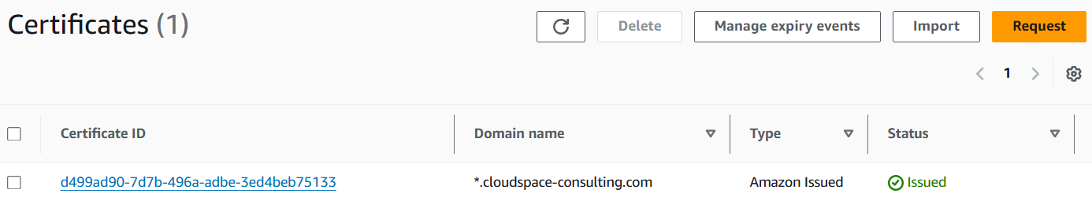

Image 1.3 – ACM certificates list

The final step is to note down **certificateARN**, which you’ll need to input as a parameter in the CloudFormation template:

* Navigate to the ACM console in the region where you created the certificate.
* Select **List Certificates** from the left pane.
* Locate your “Issued” certificate, as shown in Image 1.3.
* Click on the certificate, and under **Certificate status**, you’ll find **ARN**.

In AWS, an ARN is a unique identifier for an AWS service. It follows this format: arn:part

ition:service:region:account-id:resource-type/resource-id.

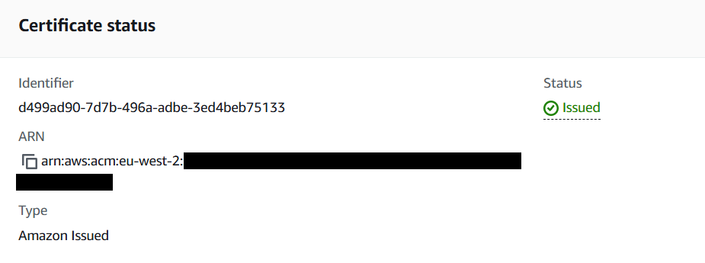

Image 1.4 – Certificate ARN access

1. **DEPLOYMENT OF THE INFRASTRUCTURE**

Now, we will deploy the infrastructure to support our application, both the frontend and backend.

1. **VPC**

* Go to VS Code and create a new folder in the directory you desire:

mkdir cooking_recipe_sharing_web_app

* Navigate to that folder and create a new folder named platform
* Navigate to the “platform” directory and create a yaml file:

touch vpc.yaml

* Copy the content of the vpc.yaml file from the provided GitHub link into it.
* Create the stack:

aws cloudformation create-stack --stack-name vpc-stack --template-body file://vpc.yaml